***Project Design Phase-I***

***Solution Architecture***

|  |  |
| --- | --- |
| Date | **03/11/2022** |
| Team ID | **PNT2022TMID43723** |
| Project Name | **Project - Natural Disasters Intensity**  **Analysis And Classification Using Artificial Intelligence** |
| Maximum Marks | **4 Marks** |

***Solution Architecture:***

Solution architecture is a complex process – with many sub-processes – that bridges the gap between business problems and technology solutions. Its goals are to:

* Find the best tech solution to solve existing business problems.
* Describe the structure, characteristics, behavior, and other aspects of the software to project stakeholders.
* Define features, development phases, and solution requirements.
* Provide specifications according to which the solution is defined, managed, and delivered.

***Example - Solution Architecture Diagram:***

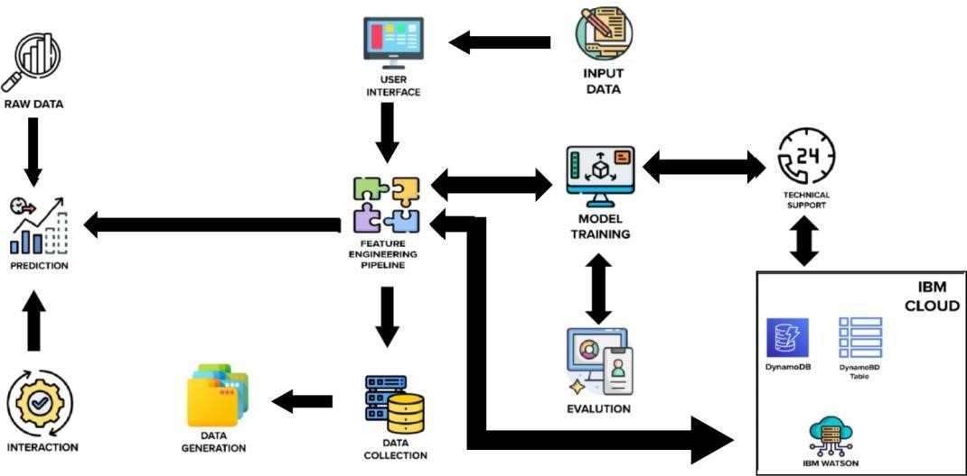

***Reference*: https://aws.amazon.com/blogs/industries/voice-applications-in-clinical-research-powered-by-ai-o n-aws-part-1-architecture-and-design-considerations/**